Functional specifications

Description | Registration and movements
Author: | H+

Changes of document
Version | Date | Author | Description
1.0 | 4.2.2004 | Matej Štefančič | Initial version

Table of contents
Changes of document 1
Table of contents 2
General description 3
Processes 4
Data validation and business rules 13

General description

Animal registration is one of the basic functions that central I&R system has to support. Registration usually starts where eartags module ends – with a new (valid) eartag applied to an animal. Most of animal registrations will enter into system through PDA module, however online registrations are also an important part of the system. In the processes section the following types of registration will be covered:
- “normal” registration – with a new eartag issued by VD
- import – in this case existing eartag may stay on animal. Another subtype of import is import to the slaughter house
- registration of stillborn cattle
All registrations can be considered as “side product” of some types of movements. Apart from movements tat come in pair with different types of registration there are also:
- departure (with optional export)
- arrival (with optional import)
- pasture
All movements can be seen as pair of departure and arrival, which are basic movements. However in some cases extra data has to be entered (import, registration, export, slaughter, death). In other cases (pasture) it is simply much more convenient for user to let I&R system do the work for him. Basic two-phase structure of a movement is show on the following picture:

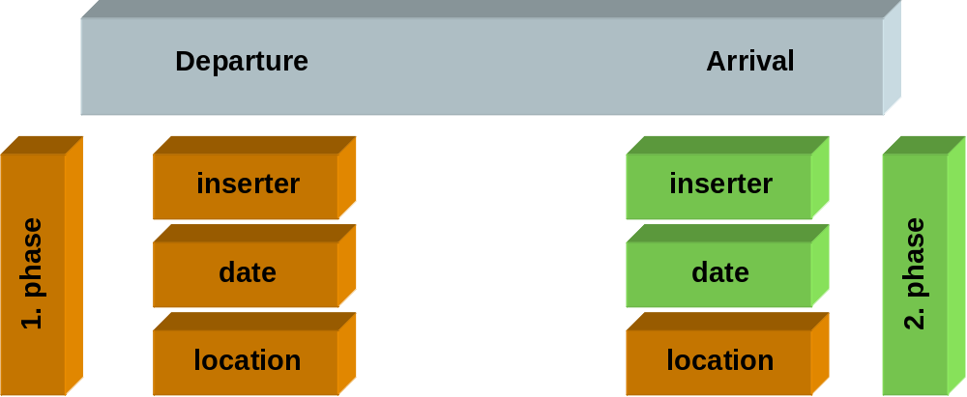

Processes

A general (and simplified) process of registration of animals is shown on the following diagram. When death/stillborn or slaughter is signal to the system, registration of animal could be needed, however this is not always the case. All processes are later explained in detail.

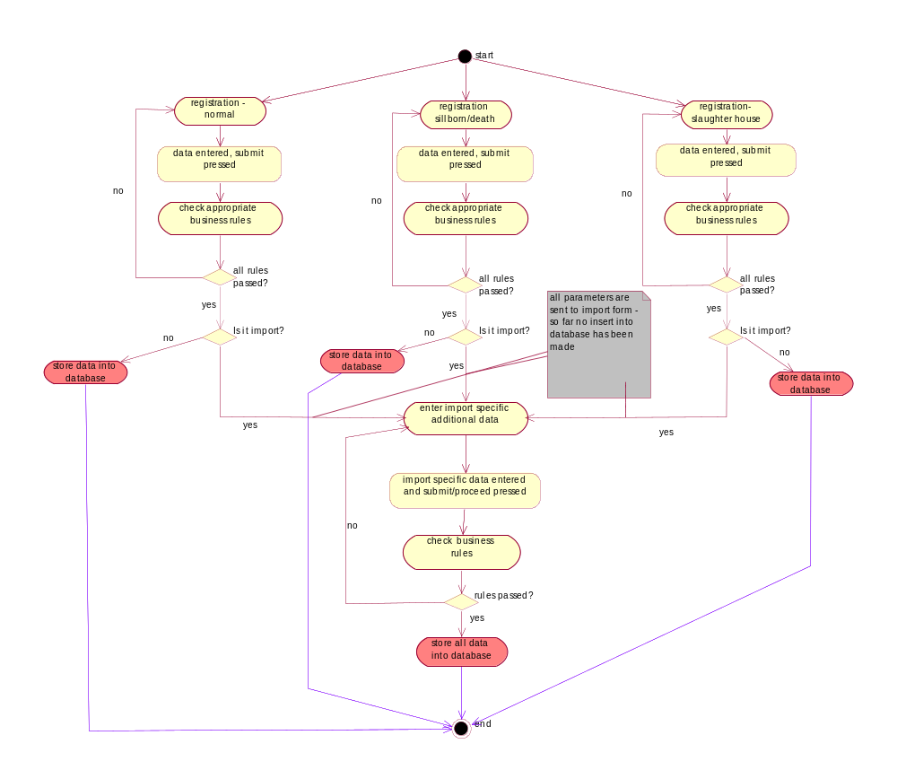

“Normal” registration – this is the most common type of registration and is usually done with the help of PDA (see also specification for PDA). In this document registration via web forms will be covered. The procedure is as follows:
- user selects “animal registration” from main web page
- a new web page is shown where user enters the following data:
  - farm id – when farm id is entered, a database request is made to retrieve related data. See business rules section to view restrictions regarding which farm id can be entered by who
  - state and eartag number – see business rules section for details regarding which eartags can be entered
  - date of birth – see business rules section for detail
  - sex
  - breed
  - mother’s state and id
  - father’s state and id
  - number of insemination document
  - date of insemination
  - marker’s id
  - date of marking
  - state and date of import (optional)
- When “proceed” button is pressed a number of business rules is checked (see business rules section). In this phase the following options are possible:
  - All checks passed – animal is successfully registered and all corresponding data is stored into appropriate tables. User receives appropriate success message. Below this message form described in step 2 is shown.
  - Data entered does not comply with business rules. In this case appropriate error message is displayed, web page described in step 2 is shown below error message and user can review/correct data entered. No data is stored in database.
  - Registration of imported animal was selected. In this case first business rules regarding “normal” registration are checked (set of business rules to be checked is very similar to the one mentioned under point a. However there are some differences - see business rules section for detail). If all required business rules passed, an import form is shown. All data from previous form is transferred to this form as hidden parameters, however only import specific data is shown to user. In addition to already filled data some additional fields that can be entered are shown. These are:
    - state breeding
    - id breeding place

When additional data is entered and “proceed” button is pressed, data is submitted to database. There all business rules are checked (“normal” registration and import specific). Both set of business rules have to be checked because there can be a significant time gap between first checking of business rules for “normal” registration and final submission of all data (user can have import form opened for a long time before he/she submits data). At this point the following situations are possible:
      - All submitted data comply with business rules. Data is stored to database, user gets success message. Under this message “normal” registration form as described in step 2 is shown.
      - Submitted data doesn’t comply with import specific business rules. In this case error message is shown and below it, import form is displayed. User has to review/correct import specific data. No data is stored to database.
      - Submitted data doesn’t comply with “normal” registration business rues. In this case error message is shown and below it, “normal” registration form is displayed. User has to review/correct entered data. No data is stored to database.

Stillborn/death registration – in some cases registration is done after the death of the animal or simply death of registered animal has to be noted in the I&R system. There are three main possibilities:
- Death – an animal which is more than 25 days old (this is a system parameter and can be set according to actual situation) dies and it has not been registered yet (no ear tag is applied)
  - A sub case of the above situation is, when an animal dies while it is imported (for example during transport)
- Death of registered animal – in this case an animal which has ear tag applied dies. In this scenario the following options are possible:
  - Animal has an ear tag, that already exists in central I&R system
  - Animal has an ear tag, however it doesn’t exist in central I&R system and no data about import is known
  - Animal has an ear tag, doesn’t exists in central I&R system and data about import is available
- Stillborn/death after birth – an animal dies at birth or within 25 days (system parameter) and it hasn’t been registered yet

All those situations are covered with one web form. Below each situation is explained in detail:
- Death of unregistered animal:
  - User selects death/stillborn option from main web page
  - a new web page is shown where user can enter the following data:
    - farm id where animal died – when farm id is entered, a database request is made to retrieve related data. See business rules section to view restrictions regarding which farm id can be entered by who
    - farm id where dead animal was taken – when this farm id is entered, a database request is made to retrieve related data. See business rules section to view restrictions regarding which farm id can be entered by whom. Entering data in this field is optional. If farm id where animal was taken is left blank, then it is automatically filled with the same value as id farm where animal died.
    - state and eartag number – in case of unregistered animal these two fields have to be left blank, because animal has no eartags applied. System defined numbers are set for this situation in phase of checking business rules
    - date of death – this data is mandatory. See business rules section for detail
    - date of birth – this field is entered if user knows it. See business rules section for detail
    - sex – male or female
    - breed – entering this data is mandatory. If breed can not be defined then NN (means NoNe) should be entered
    - mother’s state and id – in this scenario entering this field is not mandatory
    - father’s state and id - this scenario entering this field is not mandatory
    - state and date of import (optional)

  - When “proceed” button is pressed a number of business rules is checked (see business rules section). In this phase the following options are possible:
- All checks passed – animal is successfully registered and all corresponding data is stored into appropriate tables. User receives appropriate success message. Below this message form described in step b is shown.
- Data entered does not comply with business rules. In this case appropriate error message is displayed, web page described in step b is shown below error message and user can review/correct data entered. No data is stored in database.
- Death of imported animal was selected. In this case first business rules regarding death of unregistered animal are checked (set of business rules to be checked is very similar to the one mentioned under point b. However there are some differences - see business rules section for detail). If all required business rules passed, an import form is shown. All data from previous form is transferred to this form as hidden parameters, however only import specific data is shown to user. In addition to already filled data some additional fields that can be entered are shown. These are:
      - state breeding
      - id breeding place

When additional data is entered and “proceed” button is pressed, data is submitted to database. There all business rules are checked (death of unregistered animal and import specific). Both set of business rules have to be checked because there can be a significant time gap between first checking of business rules for death of unregistered animal and final submission of all data (user can have import form opened for a long time before he/she submits data). At this point the following situations are possible:
      - All submitted data comply with business rules. Data is stored to database, user gets success message. Under this message death/stillborn web form is shown.
      - Submitted data doesn’t comply with import specific business rules. In this case error message is shown and below it, import form is displayed. User has to review/correct import specific data. No data is stored to database.
      - Submitted data doesn’t comply with death of unregistered animal specific business rules. In this case error message is shown and below it, death/stillborn form is displayed. User has to review/correct import specific data. No data is stored to database.

- Death of registered animal:
  - User selects death/stillborn option from main web page
  - a new web page is shown where user can enter the following data:
    - farm id where animal died – when farm id is entered, a database request is made to retrieve related data. See business rules section to view restrictions regarding which farm id can be entered by who
    - farm id where dead animal was taken – when this farm id is entered, a database request is made to retrieve related data. See business rules section to view restrictions regarding which farm id can be entered by whom. Entering data in this field is optional. If farm id where animal was taken is left blank, then it is automatically filled with the same value as id farm where animal died.
    - state and eartag number – in case of registered animal these two fields are mandatory, because animal has eartags applied. If ear tag number already exists in central I&R system than this animal had to have confirmed arrival or departure to farm where animal died before date of death
    - date of death – this data is mandatory. See business rules section for detail.
    - date of birth – after entering state and id animal and if this state and id animal (ear tag number) already exist in central I&R system, then this field is filled automatically. Otherwise entering this field is optional.
    - sex – male or female (mandatory). After entering state and id animal and if this state and id animal (ear tag number) already exist in central I&R system, then this field is filled automatically
    - breed – entering this data is mandatory. If breed can not be defined then NN (means NoNe) should be entered. After entering state and id animal and if this state and id animal (ear tag number) already exist in central I&R system, then this field is filled automatically
    - mother’s state and id – in this scenario entering this field is not mandatory, however is state and id animal fields are entered and if this state and id animal (ear tag number) already exist in central I&R system, then this field is filled automatically
    - father’s state and id - this scenario entering this field is not mandatory, however is state and id animal fields are entered and if this state and id animal (ear tag number) already exist in central I&R system, then this field is filled automatically
    - state and date of import (optional) – if state and id animal fields are entered and if this state and id animal (ear tag number) already exist in central I&R system than entering state and date of import is disabled
  - When “proceed” button is pressed a number of business rules is checked (see business rules section). In this phase the following options are possible:
- All checks passed – animal is successfully registered and all corresponding data is stored into appropriate tables. User receives appropriate success message. Below this message form described in step b is shown.
- Data entered does not comply with business rules. In this case appropriate error message is displayed, web page described in step b is shown below error message and user can review/correct data entered. No data is stored in database.
- Death of imported animal was selected. In this case first business rules regarding death of unregistered animal are checked (set of business rules to be checked is very similar to the one mentioned under point b. However there are some differences - see business rules section for detail). If all required business rules passed, an import form is shown. All data from previous form is transferred to this form as hidden parameters, however only import specific data is shown to user. In addition to already filled data some additional fields that can be entered are shown. These are:
      - state breeding
      - id breeding place

When additional data is entered and “proceed” button is pressed, data is submitted to database. There all business rules are checked (death of unregistered animal and import specific). Both set of business rules have to be checked because there can be a significant time gap between first checking of business rules for death of unregistered animal and final submission of all data (user can have import form opened for a long time before he/she submits data). At this point the following situations are possible:
      - All submitted data comply with business rules. Data is stored to database, user gets success message. Under this message death/stillborn web form is shown.
      - Submitted data doesn’t comply with import specific business rules. In this case error message is shown and below it, import form is displayed. User has to review/correct import specific data. No data is stored to database.
      - Submitted data doesn’t comply with death of registered animal specific business rules. In this case error message is shown and below it, death/stillborn form is displayed. User has to review/correct import specific data. No data is stored to database.

- Stillborn/death after birth – this situation is very similar to death of unregistered animal scenario:
  - User selects death/stillborn option from main web page
  - a new web page is shown where user can enter the following data:
    - farm id where animal died – when farm id is entered, a database request is made to retrieve related data. See business rules section to view restrictions regarding which farm id can be entered by who
    - farm id where dead animal was taken – when this farm id is entered, a database request is made to retrieve related data. See business rules section to view restrictions regarding which farm id can be entered by whom. Entering data in this field is optional. If farm id where animal was taken is left blank, then it is automatically filled with the same value as id farm where animal died.
    - state and eartag number – in case of stillborn animal these two fields have to be left blank, because animal has no eartags applied. System defined numbers are set for this situation in phase of checking business rules
    - date of death – this data is mandatory. See business rules section for detail
    - date of birth – this field is mandatory. See business rules section for detail
    - sex – male or female
    - breed – entering this data is mandatory. If breed can not be defined then NN (means NoNe) should be entered
    - mother’s state and id – in this scenario entering this field is mandatory
    - father’s state and id – in this scenario entering this field is not mandatory
    - state and date of import - in this scenario these two fields are disabled

  - When “proceed” button is pressed a number of business rules is checked (see business rules section). In this phase the following options are possible:
- All checks passed – animal is successfully registered and all corresponding data is stored into appropriate tables. User receives appropriate success message. Below this message form described in step b is shown.
- Data entered does not comply with business rules. In this case appropriate error message is displayed, web page described in step b is shown below error message and user can review/correct data entered. No data is stored into database.

Slaughtering – during slaughtering the following scenarios may occur:
- slaughtering of registered animal
- import of animal to slaughter house and slaughtering
Slaughter can be signaled to the central I&R system in the following ways:
- via web forms (this option is explained in detail in this document)
- via XML data exchange (see XML-slaughtering specifications for detail)

Both types of slaughtering are covered with one web form. The procedure of entering data is as follows:
- user selects “slaughtering” option from the main web page
- a new web page is show where the following data must be entered:
  - state and id animal which was slaughtered –this field is optional (otherwise it is not possible to enter slaughtering for imported animals that do not have ear tags, or for unregistered “home” animals).
  - farm id from where animal came (farm departure) – if id animal entered in step 1 is registered in central I&R system then this field is filled automatically based on last confirmed arrival noted into the system.
  - farm id where animal was slaughtered (farm arrival) - see business rules section for detail which farm id can be entered
  - date of arrival on the farm where slaughtering was done – if slaughtering took place on the same farm as animal was before (based on last confirmed arrival noted in the system) then this field is filled automatically with date arrival to this farm
  - date of slaughtering – this field is mandatory
  - slaughter no – number of appropriate veterinary document
  - mass type – live weight or warm halves
  - mass
  - state and date of import – if state and id animal entered in step a indicate that animal is registered into central I&R system then this field is disabled. The only exception to this rule is, when last movement of this animal was export – in this case animal can be (re)imported
- When “proceed” button is pressed a number of business rules is checked (see business rules section). In this phase the following options are possible:
- All checks passed – animal slaughter and all corresponding data are stored into appropriate tables. User receives appropriate success message. Below this message form described in step 2 is shown.
- Data entered does not comply with business rules. In this case appropriate error message is displayed, web page described in step 2 is shown below error message and user can review/correct data entered. No data is stored in database.
- Slaughtering of imported animal was selected. In this case first business rules regarding slaughtering of animal are checked (set of business rules to be checked is very similar to the one mentioned under point 2. However there are some differences - see business rules section for detail). If all required business rules passed, an import form is shown. All data from previous form is transferred to this form as hidden parameters, however only import specific data is shown to user. In addition to already filled data some additional fields that can be entered are shown. These are:
      - state breeding
      - id breeding place

When additional data is entered and “proceed” button is pressed, data is submitted to database. There all business rules are checked (slaughtering of animal and import specific). Both set of business rules have to be checked because there can be a significant time gap between first checking of business rules slaughtering and final submission of all data (user can have import form opened for a long time before he/she submits data). At this point the following situations are possible:
      - All submitted data comply with business rules. Data is stored to database, user gets success message. Under this message slaughtering web form is shown.
      - Submitted data doesn’t comply with import specific business rules. In this case error message is shown and below it, import form is displayed. User has to review/correct import specific data. No data is stored to database.
      - Submitted data doesn’t comply with slaughtering specific business rules. In this case error message is shown and below it, slaughtering form is displayed. User has to review/correct import specific data. No data is stored to database.

Pasture – especially during summer large number of movements is connected to pasturing. There are two different type of pasture:
- mountain pasture – usually at the beginning of summer animals are taken to the mountain pasture and at the beginning of autumn they are returned to “home” stables
- village pasture – every day animal is taken to the village pasture and at the end of the day it returns to the home stable

Inserting data for both types of pasture is covered with one web form, according to the following procedure:
- user selects “pasture” option from the main web page
- a new web page is show where the following data must be entered:
  - farm id from where animals are going to the pasture
  - farm id of the pasture, where animals are going to
  - date of going to the pasture (in case of village pasture the date of first departure to the pasture should be entered)
  - expected date of return from the pasture (in case of village pasture the date of last arrival from the pasture should be entered)
  - type of pasture must be selected (mountain or village)
  - list of animals (state, id animal) that are going from farm entered under step a to the pasture. See business rules section for business rules regarding which animals can be inserted into this list
- when all data is entered and “proceed” button is pressed, business rues are checked. During this phase the following situations may occur:
  - All checks passed – animal is successfully registered and all corresponding data is stored into appropriate tables. User receives appropriate success message. Below this message form described in step 2 is shown. In database departure to the pasture and arrival from it are noted. In case of village pasture, for every day from first departure to last arrival planned movements are stored. Each day, a database job checks for any declared movements and if conditions are met, movement is written into “real” tables. See business rules section for details.
  - Data entered does not comply with business rules. In this case appropriate error message is displayed, web page described in step 2 is shown below error message and user can review/correct data entered. No data is stored in database

Arrival – this is a basic function of every animal I&R system. Pair of departure-arrival form every movement. All previously mentioned processes could be seen as special cases of arrival or departure. At arrival the following situations may occur:
- Arrival from known farm
- Arrival from unknown farm
- Import

One web form covers all those situations. The procedure is as follows:
- user selects “arrival” option from the main web page
- a new web page is show where the following data must be entered:
  - state and id animal which arrived –this field is mandatory.
  - farm id from where animal came (farm departure) – this field is also mandatory, however it is not necessary that a valid farm id is entered - see business rules for detail.
  - farm id where animal arrived (farm arrival) - see business rules section for detail which farm id can be entered
  - date of arrival– this field is mandatory. Date of arrival has to be in the past
  - state and date of import – if state and id animal entered in step a indicate that animal is registered into central I&R system then this field is disabled. The only exception to this rule is, when last movement of this animal was export – in this case animal can be (re)imported
- When “proceed” button is pressed a number of business rules is checked (see business rules section). In this phase the following options are possible:
- All checks passed – animal arrival and all corresponding data are stored into appropriate tables. User receives appropriate success message. Below this message form described in step 2 is shown.
- Data entered does not comply with business rules. In this case appropriate error message is displayed, web page described in step 2 is shown below error message and user can review/correct data entered. No data is stored in database.
- Arrival of imported animal was selected (this is only valid for animals that were exported first). In this case first business rules regarding arrival of animal are checked (set of business rules to be checked is very similar to the one mentioned under point 2. However there are some differences - see business rules section for detail). If all required business rules passed, an import form is shown. All data from previous form is transferred to this form as hidden parameters, however only import specific data is shown to user. In addition to already filled data some additional fields that can be entered are shown. These are:
      - state breeding
      - id breeding place

When additional data is entered and “proceed” button is pressed, data is submitted to database. There all business rules are checked (arrival of animal and import specific). Both set of business rules have to be checked because there can be a significant time gap between first checking of business rules slaughtering and final submission of all data (user can have import form opened for a long time before he/she submits data). At this point the following situations are possible:
      - All submitted data comply with business rules. Data is stored to database, user gets success message. Under this message slaughtering web form is shown.
      - Submitted data doesn’t comply with import specific business rules. In this case error message is shown and below it, import form is displayed. User has to review/correct import specific data. No data is stored to database.
      - Submitted data doesn’t comply with arrival specific business rules. In this case error message is shown and below it, arrival form is displayed. User has to review/correct import specific data. No data is stored to database.

Data validation and business rules

Business rules for “normal” registration

- User has to have privilege to register animals on farm specified
- Date of registration can not be set in the future
- State of animal has to be a valid state (short name according to ISO notation)
- Only a valid and new (not already applied) can be used for “normal ”registration of animal
- At time of birth, mother has to be on farm where birth happened
- Date of birth can not be set into the future
- Mother has to be alive at the time of birth
- Mother has to be at least 17 months old (system parameter, that can be set according to actual needs), before she can give birth.
- Time between two calving dates has to be at least as long as value for claving_period system parameter is set.
- Mother can not be mother to herself
- Mother can note male
- Father can not be female

Business rules for death/stillborn

To decide which scenario within this section should be checked, the following decision tree should be followed:

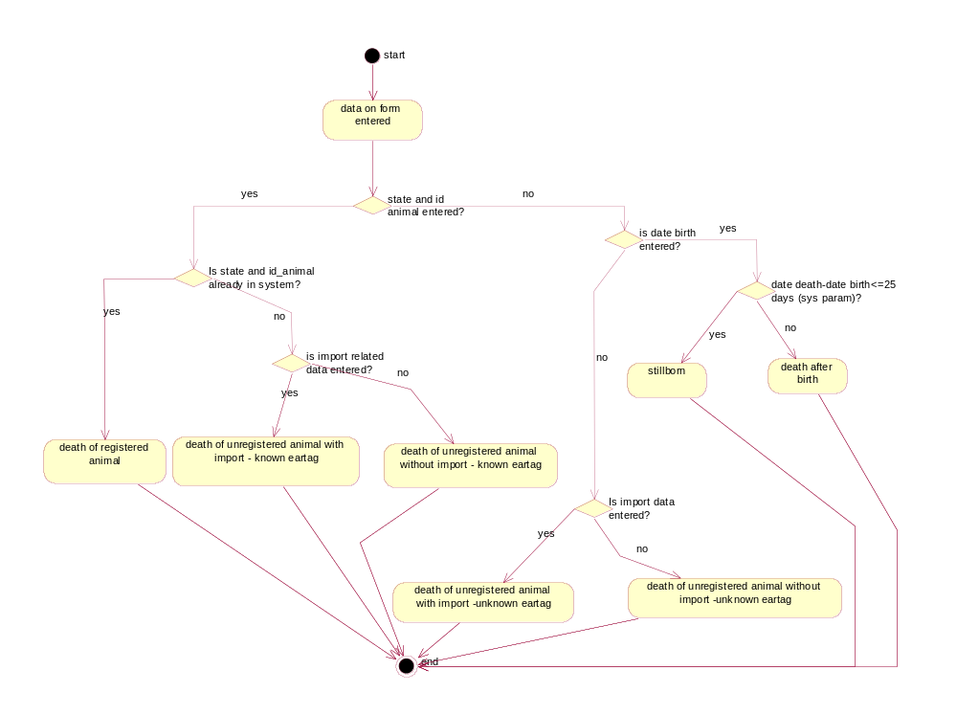

additional business rules for death/stillborn:

Business rules - pasture

Apart from business rules defined in processes section, the following business rules apply for pasture:
- in list of animal only those animals can be entered, which are at the moment of inserting data present at the “home” farm
- animals can not be put automatically from one pasture to another. When such cases occur, a separate movement has to be entered signaling that animal went from one pasture to another. “Pasture” may not be used in such cases, that’s why entering a pasture as farm from which animal depart will result in error.
- System automatically inserts “real” movements based on “declared” movements if no other movements, for this animal, occur during specified period. If anything unexpected happens (for example departure from pasture that wasn’t in movement declaration for pasture), then all remaining declarations for this animal become invalid.

Business rules - slaughtering

Apart from business ruled defined in processes section the following rules apply for slaughtering:
- if user comes from organization that can operate on only one farm (farmers, slaughter houses,…) than only this farm id can be entered into farm id arrival. Otherwise farm id has to be from the list of farms on which user can operate.
- animal can not be slaughtered if it is younger than 25 days. Age before slaughtering is a system parameter, which can be adjusted to actual needs/situation
- at slaughtering arrival to the slaughter house (can overrun last departure in the following scenario:
  - at farm A, departure for animal XX to the slaughter house B was signaled
  - at slaughter house C arrival of animal XX is signaled, where date of arrival is within plus/minus two days from date of departure from farm A
  - if both previous conditions are met, then movement is automatically corrected to have departure to slaughter house C with actual date of arrival. Previous data (farm id arrival) is stored into notes for this movement.

Business rules – arrival

Apart from business ruled defined in processes section the following rules apply for arrival:
- if farm departure is not registered, then 100000014 has to be entered (this is a system parameter and can be changed). In this case all fields regarding holder keeper (name, family name) and farm (address, zip code, zip code name) have to be entered.
- if user comes from organization that can operate on only one farm (farmers, slaughter houses,…) than only this farm id can be entered into farm id arrival. Otherwise farm id has to be from the list of farms on which user can operate. If farm arrival is not registered then 100000027 has to be entered (this is a system parameter and can be changed). In this case all fields regarding holder keeper (name, family name) and farm (address, zip code, zip code name) have to be entered

